SESSION 11 ASSIGNMENT 2

**Problem Statement:**

Perform incremental load in Hive

Read from MySQL Table and load it in Hive table.

Create hive table if it does not exist.

If it exists, perform the incremental load.

**Solution/Approach:**

1 -> We will start all the Hadoop resources and sql service.

Start-all.sh

Sudo service mysqld start

2 -> Now we will login to SQl interface and create a new table employee and insert few records into it.

Mysql -u root

Create database session_11;

Use session_11;

Create table employee(

Id int,

Name varchar(24),

Grade varchar(02));

INSERT INTO employee VALUES(1,’Aman’,’A4’);

INSERT INTO employee VALUES(2,’Ankit’,’A4’);

INSERT INTO employee VALUES(3,’Prachi’,’A4’);

INSERT INTO employee VALUES(4,’Sonakshi’,’B1’);

Exit;

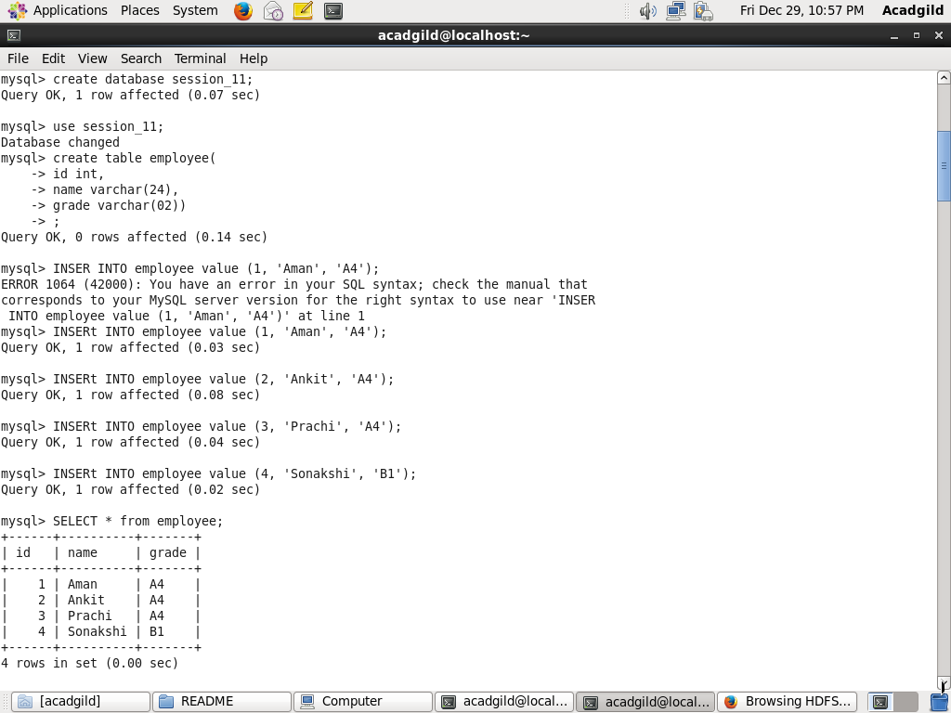

3 -> Importing the employee table from SQl to Hive using Sqoop.

sqoop import -connect jdbc:mysql://localhost/session_11 -username ‘root’ -P -table employee --hive-import -m1;

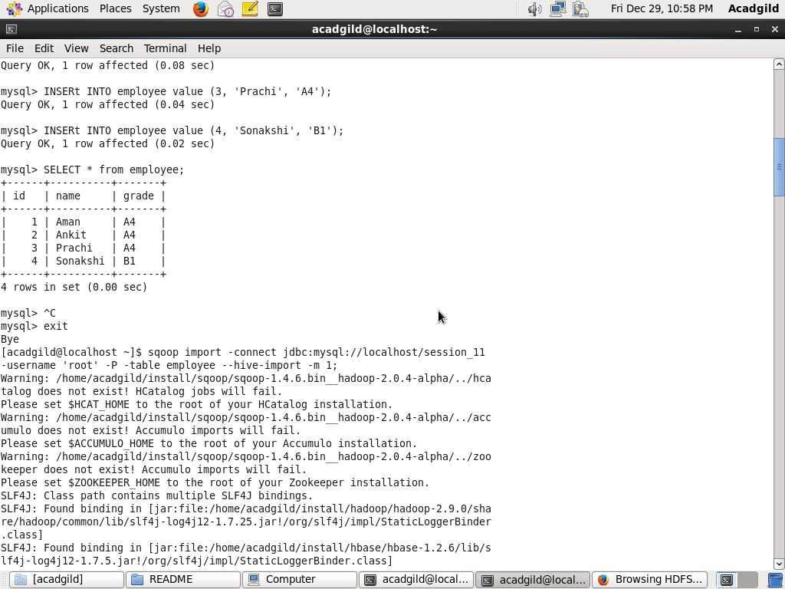

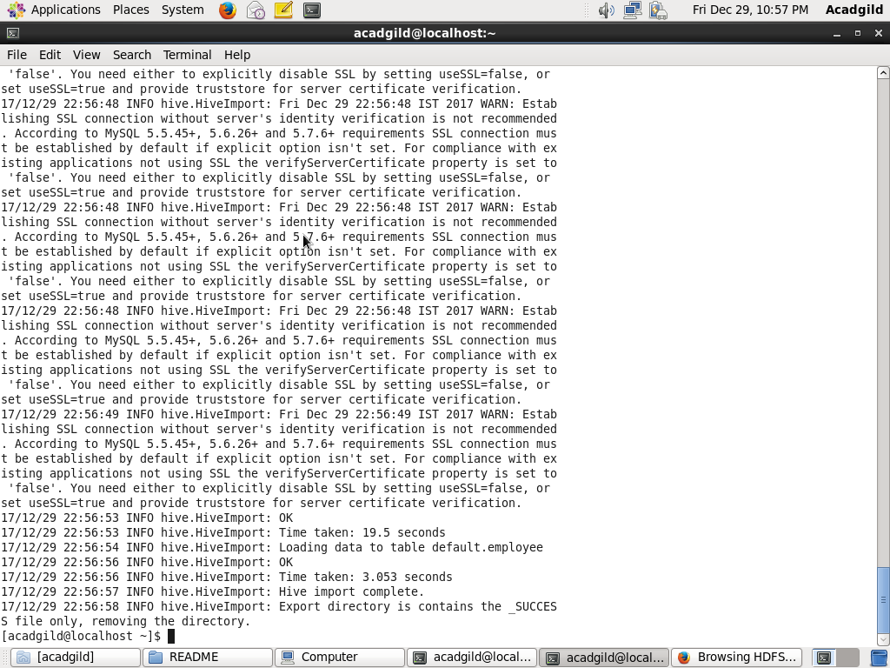

4 -> Checking in hive if table was created or not.

Hive

Show tables;

Select * from employee;

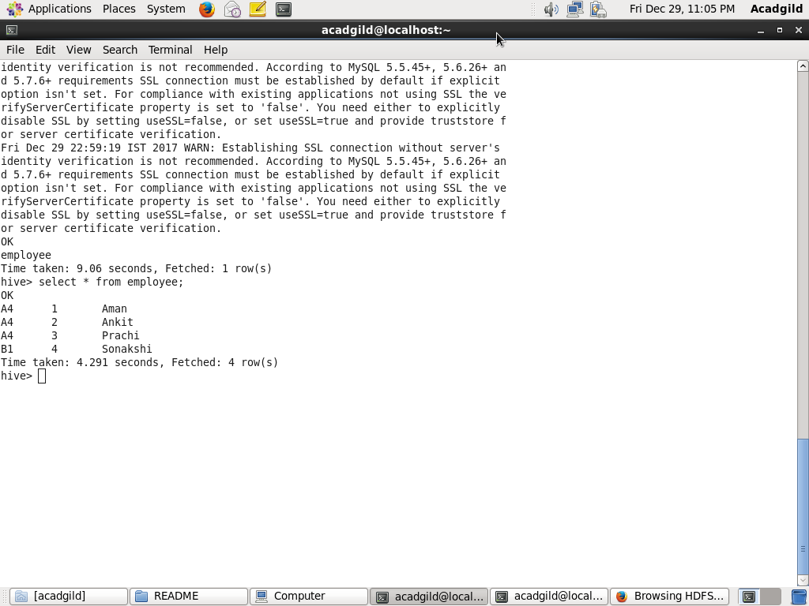

INCREMENTAL LOAD

5 -> Inserting new records in sql table employee.

Mysql -u root

Use session_11;

INSERT INTO employee VALUES(5,’Ram’,’B1’);

INSERT INTO employee VALUES(6,’Shiva’,’B1’);

Exit;

6 -> Doing Incremental load via sqoop

sqoop import -connect jdbc:mysql://localhost/session_11 -username ‘root’ -P -table employee --hive-import --hive-table employee -check-column id --incremental-append --last-value 4 -m1;

7 -> After successful load we will create external table in hive and then create a view by doing union of base table employee and external table created.

hive

create external table incremental_employee(

grade string,

id int,

name string)

row format delimited

fields terminated by ‘ , ‘

location ‘user/acadgild/employee’;

select * from incremental_employee;

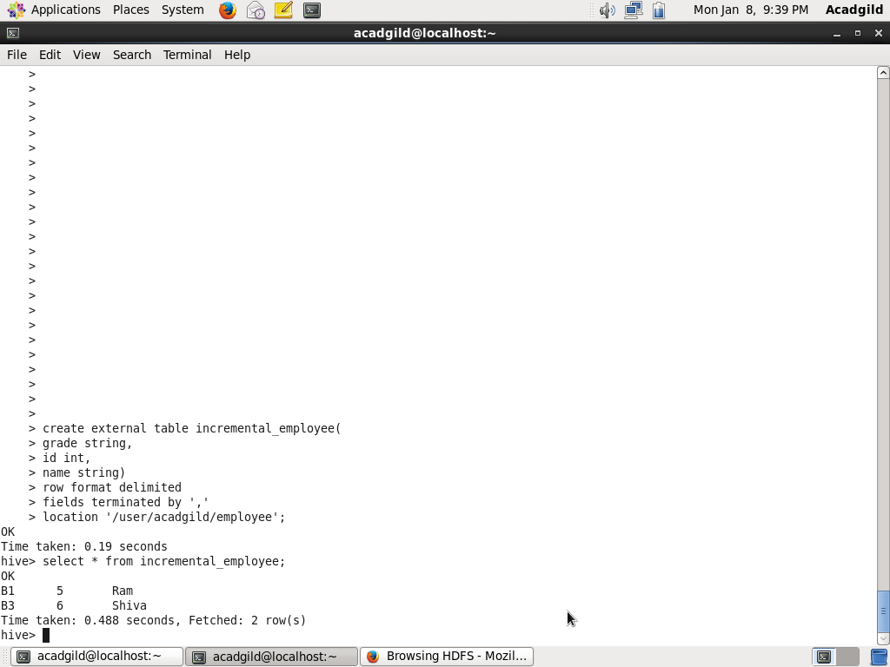

Create view employee_table as

Select t1.* from (

Select * from employee

UNION ALL

Select * from incremental_employee

)t1

Select * from employee_table;

